RELATIVE CLAUSES: WHO, THAT, WHICH, WHERE.
Complete the sentences using a Relative Clause or (-) when it is possible.
- I’d like to meet all the people ……………………work with you.
- That’s the old house…………….we live when we were children.
- I was lucky enough to meet a policeman……………told me the way.
- That’s the place…………………my father does the cooking. He’s a chef.
- Pick up the book………………..he has dropped.
- Can you empty the rubbish bin…………….. is in the kitchen please?
- Show me the house……………….is Brian’s please!
Choose the correct relative pronoun.
- This is the bank THAT/ WHERE / - I work.
- A boy WHICH/WHO is in my class was in the bank at that time.
- That is the man WHICH / - / WHO wears a mask of Mickey Mouse.
- A friend was waiting outside in the car THAT/WHERE was on.
- The woman - / THAT / WHO gave him the money was young.
- The bag WHERE / THAT contained the money was yellow.
- This is the supermarket WHICH / WHERE / - you can buy candies.

- Defining relative clauses. Who, which, - , when and where.
- What´s the name of the skiing resort __________ you stayed last Christmas?
- Laura is the girl __________ creates a new video game.
- Those are the tourists ___________ we met at the airport.
- Can you remember the time _________ you lived in Italy?
- The police found the car _______ was stolen.
- That is the shop _________ you can buy homemade food.
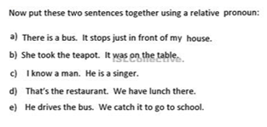
- Do you remember ________ was the last time you go to the shopping mall?

